**CSE1100 – Programming Concepts with Python**

**Programming Concepts Lab Report**

**Fall 2021**

*By*

Cael Shoop

*Computer Science, B.S.*

*cshoop2018@my.fit.edu*

September 17, 2021

Homework or Lab #3

Teaching Instructor:

Stefan Joe-Yen, Ph.D.

# 1. Problem Statement

Problem 1

A random number generator is needed that allows the user to guess the value, and hints whether they or higher or lower than the selected value.

Problem 2

A menu is needed that allows the user to select an option and do one of 4 conversions, or quit.

# 2. Requirements

Problem 1

1. The software shall select a random value between 1 and 500.
2. The software shall take input from the user.

2.1 The software shall notify the user if their input is higher or lower than the selected value.

2.2 The software shall notify the user of their remaining guesses.

1. The software shall quit when either the user guesses the number or runs out of guesses.

Problem 2

1. The software shall display a menu to receive user input.
   1. The user menu shall contain the options for different conversions.
   2. The user menu shall display an option to terminate the program.
2. The software shall store inputs using variables.
3. The software shall convert the inputs based on the option chosen from the menu.

# 3. Software Construction (Annotated Python Code)

*This section includes the software implementation of the design provided in section 3—it includes annotated explanations of well-formatted and commented Python code. Students shall follow coding guidelines (given by Faculty/TA) to ensure high-quality software. Example is presented below.*

Problem 1

'''Written by Cael Shoop. Lab 3, Problem 1.'''

import random

def main():

print('Welcome to Guessing Game!')

print('Please guess a number from 1 to 500:')

guess = 0

guesses = 5

value = random.randrange(1, 500)

while (guess != value and guesses > 0):

guess = int(input())

guesses = guesses - 1

if (guess < value) and (guesses > 1):

print(f"That's too low! Try again ({guesses} guesses left).")

elif (guess > value) and (guesses > 1):

print(f"That's too high! Try again ({guesses} guesses left).")

elif (guess < value) and (guesses > 0):

print(f"That's too low! Last chance ({guesses} guesses left).")

elif (guess > value) and (guesses > 0):

print(f"That's too high! Last chance ({guesses} guesses left).")

elif (guess < value):

print("That's too low! Better luck next time.")

elif (guess > value):

print("That's too high! Better luck next time.")

else:

print('You got it! Good job.')

if __name__ == '__main__':

try:

main()

except:

print('Error: Main failed.')

else:

print('Please run this program independently.')

Problem 2

'''Written by Cael Shoop. Lab 3, Problem 2.'''

import math

def main():

print('Welcome to Converter.')

choice = 0

while (choice != 5):

invalid = 1

print('Please select from the following conversions:')

print('\t(1) Kelvin to Fahrenheit')

print('\t(2) Fahrenheit to Kelvin')

print('\t(3) Yards to Meters')

print('\t(4) Meters to Yards')

print('\t(5) Quit')

while (invalid == 1):

try:

choice = int(input('Enter a selection number: '))

if (choice < 1 or choice > 5):

print('Sorry, that is not a valid choice!')

invalid = 1

else:

invalid = 0

except:

print('Sorry, that is not a valid choice!')

invalid = 1

if (invalid == 0):

if (choice == 1):

kelvin = float(input('OK - Kelvin to Fahrenheit. Enter a temperature in Kelvin: '))

celsius = kelvin - 273.15

fahrenheit = celsius * (9/5) + 32

fahrenheit = round(fahrenheit, 4)

print(f'Thanks. {kelvin} Kelvin is {fahrenheit} Fahrenheit.')

elif (choice == 2):

fahrenheit = float(input('OK - Fahrenheit to Kelvin. Enter a temperature in Fahrenheit: '))

celsius = (fahrenheit - 32) * (5/9)

kelvin = celsius + 273.15

kelvin = round(kelvin, 4)

print(f'Thanks. {fahrenheit} Fahrenheit is {kelvin} Kelvin.')

elif (choice == 3):

yards = float(input('OK - Yards to Meters. Enter a distance in yards: '))

meters = yards * 0.9144

meters = round(meters, 4)

print(f'Thanks. {yards} Yards is {meters} Meters.')

elif (choice == 4):

meters = float(input('OK - Meters to Yards. Enter a distance in meters: '))

yards = meters / 0.9144

yards = round(yards, 4)

print(f'Thanks. {meters} Meters is {yards} Yards.')

else:

print('Thanks for using Converter. Goodbye.')

if __name__ == '__main__':

try:

main()

except:

print('Error: Main failed.')

else:

print('Please run this program independently.')

# 4. Software Testing

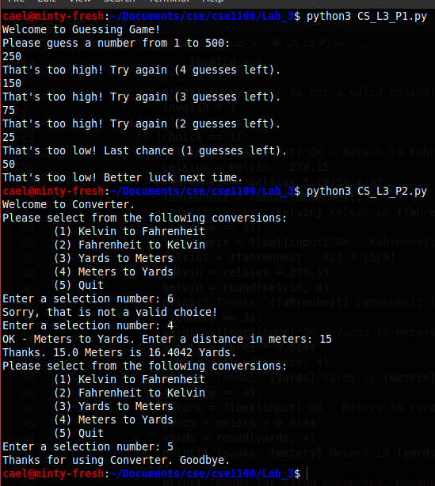

# 5. Self-Reflection

Getting to practice while loops in Python was useful, as well as testing out more try/except statements. The math was easy to implement and they were fun programs to write.